Electronic Voting Machine

**Submitted by**:

Sai Rohith -21ECB058

Anusha - 21ECB0B59

Bhavya – 21ECB0B60

Taras Rajan - 21ECB0B61

**Submitted to**:

IC LAB



DEPARTMENT OF ELECTRONICS AND COMMUNICATION ENGINEERING

NATIONAL INSTITUTE OF TECHNOLOGY, WARANGAL

**2022-2023**

# ACKNOWLEDGEMENT

We would like to express my utmost gratitude to our faculty in-charge **Dr. Ravi Kumar Jatoth, Professor**, Department of Electronics and Communication Engineering and National Institute of Technology, Warangal for their constant supervision, guidance, suggestion and encouragement during this semester.

**TABLE OF CONTENTS:**

* Abstract
* Components Required
* Circuit Diagram
* Working of Circuit
* Results
* Application and Future scope
* Conclusion
* References

# ABSTRACT

This project we propose an Electronic Voting Machine (EVM) system that is designed to be transparent and operates digitally, ensuring that the voting process is fair and open. This Electronic Voting Machine responds on some flow of pulses coming from the switch operated by voter and produces the output of the counting values i.e. total casting votes of individual nominee and displays it. The machine is controlled manually to operate the system for successive voters and to ensure that a voter can give only one vote to his/her chosen candidate of the same position. The manual controlling system must be operated by some authorized officer who have to check and declare whether a voter can vote or not. Designing and implementing of this Voting machine system is very plain and convenient due to having digital circuitry.

**INTRODUCTION**

An Electronic Voting Machine (EVM) is a device that has revolutionized the electoral process around the world. Unlike traditional paper ballot systems, EVMs use digital technology to record votes and generate results. The use of EVMs has brought about many benefits such as speed, accuracy, and transparency, making the voting process more efficient and trustworthy. The EVM system can be customized to accommodate diverse voters and can also include security features such as encryption and authentication to prevent fraud and hacking. The aim of this technology is to provide a fair and free election system that is accessible to all and can deliver accurate and prompt results.

**DESIGN OVERVIEW**

**COMPONENTS REQUIRED:**

|  |  |  |
| --- | --- | --- |
| **Component** | **Count** | **Cost (per piece)** |
| IC 7408 | 2 | 20/- |
| IC 7432 | 1 | 20/- |
| IC 7493 | 5 | 40/- |
| IC 7447 | 4 | 45/- |
| Resistor (1k) | 2 | 0.5/- |
| 7 Segment Display | 4 | 20/- |
| Push Button | 2 | 2/- |
| Slide Switch | 1 | 6/- |
| Wires | - |  |

**COMPONENTS OF POWER SUPPLY:**

|  |  |  |
| --- | --- | --- |
| **Component** | **Count** | **Cost** |
| IC 7805 | 1 | 6/- |
| IN 4007 | 4 | 4.5/- |
| Transformer | 1 | 450/- |
| Capacitor | 2 | 5/- |

**5-V POWER SUPPLY USING TRANSFORMER**

# 

* In this project we have used this circuit to generate 5 volts constant dc voltage using a Centre tapped transformer, bridge rectifiers, voltage regulator and capacitors.

**WORKING**

A 5V power supply circuit using a transformer is a device that converts high voltage, typically from a wall outlet, into low voltage for powering electronic devices. The circuit includes a transformer, which has two coils of wire wrapped around a core. The primary coil, connected to the high voltage source, induces a magnetic field that causes an alternating current (AC) to flow in the secondary coil, which is connected to the low voltage circuit.

The transformer then passes the AC voltage to a bridge rectifier, which converts the AC voltage to DC voltage. The DC voltage is then smoothed out by a filter capacitor to remove any ripples in the voltage, resulting in a stable 5V DC output voltage.

This circuit also includes IC7805 voltage regulator to ensure a constant output voltage regardless of input voltage fluctuations. The voltage regulator adjusts the output voltage by varying the amount of current flowing through the circuit.

In summary, a 5V power supply circuit using a transformer works by converting high voltage to low voltage using a transformer, rectifying the AC voltage to DC voltage, and smoothing out the voltage with a filter capacitor to produce a stable 5V DC output.

**IC 7408:**

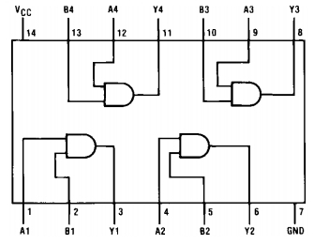

IC 7408 is a quad 2-input AND gate, which is a type of logic gate that performs the logical AND operation on two input signals. The IC 7408 consists of four separate AND gates, each with two inputs and one output.

The IC 7408 has a 14-pin dual in-line package (DIP) and can operate at a wide range of supply voltages from 4.75V to 5.25V. It uses Transistor-Transistor Logic (TTL) technology and has a typical propagation delay of 10 nanoseconds.

**IC 7432:**

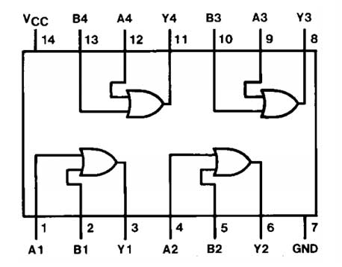

IC 7432 is a quad 2-input OR gate, which is a type of logic gate that performs the logical OR operation on two input signals. The IC 7432 consists of four separate OR gates, each with two inputs and one output.

The IC 7432 has a 14-pin dual in-line package (DIP) and can operate at a wide range of supply voltages from 4.75V to 5.25V. It uses Transistor-Transistor Logic (TTL) technology and has a typical propagation delay of 10 nanoseconds.

**IC 7493:**

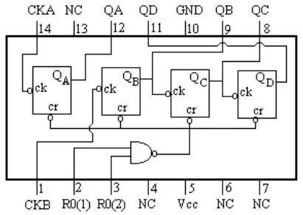

IC 7493 is a 14-pin binary counter integrated circuit (IC) that is used to divide the input clock signal by a power of two. It consists of four master-slave flip-flops, each of which can divide the clock frequency by two, thus providing a total of divide-by-2, divide-by-4, divide-by-8, or divide-by-16 counting modes.

The IC 7493 has two inputs: clock input (CLK) and a reset input (RST). The CLK input is used to drive the counter, and each rising edge of the CLK signal causes the counter to increment by one. The RST input is used to reset the counter to zero when it is asserted.

The output of the IC 7493 consists of four binary outputs labeled Q0, Q1, Q2, and Q3, representing the current count value in binary form. The Q0 output is the least significant bit (LSB), and the Q3 output is the most significant bit (MSB).

**IC 7447:**

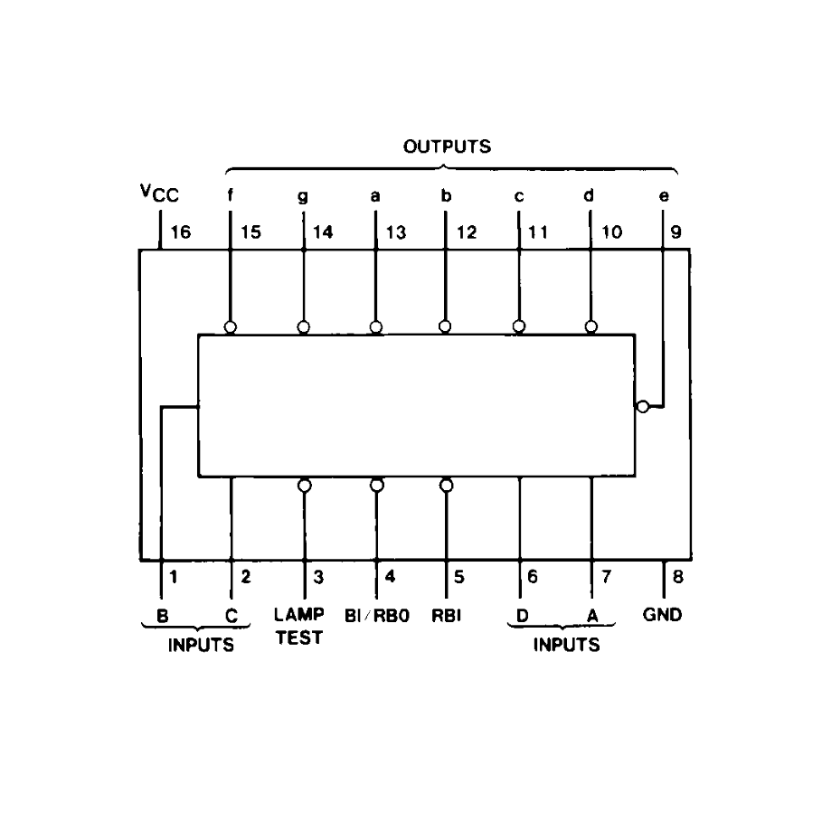

IC 7447 is a BCD-to-7-segment decoder/driver IC, which is used to convert binary-coded decimal (BCD) into a form suitable for display on a 7-segment LED display. The IC 7447 consists of a latch, a BCD-to-7-segment decoder, and an output buffer.

The IC 7447 has a 16-pin dual in-line package (DIP) and can operate at a wide range of supply voltages from 4.75V to 5.25V. It uses Transistor-Transistor Logic (TTL) technology and has a typical propagation delay of 25 nanoseconds.

The inputs of the IC 7447 consist of four BCD inputs (A, B, C, and D), which represent the BCD input number to be displayed. The IC 7447 converts the BCD input into the corresponding 7-segment display output and provides these outputs (a through g) to drive a common-cathode 7-segment LED display.

The IC 7447 also has a lamp test input (LT) and a blanking input (BI), which are used to test the display and blank the display, respectively.

**7 SEGMENT DISPLAY:**

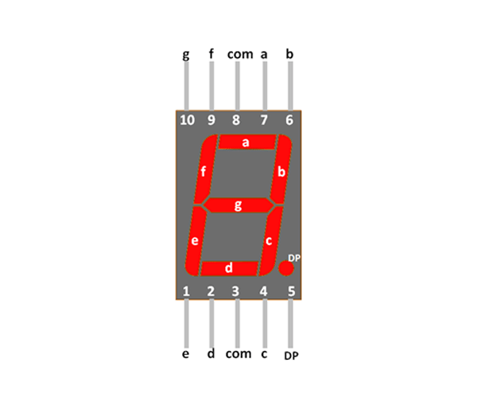

A 7-segment display common anode is a type of electronic display device that consists of seven segments arranged in the shape of the digit "8". Each segment can be individually turned on or off to display a variety of numbers and letters.

In a common anode 7-segment display, all of the anodes of the seven segments are connected together and tied to a positive voltage supply. Each segment has a cathode that is connected to a driver circuit that can turn the segment on or off by applying a low voltage (ground) or a high voltage (positive supply) to it.

To display a particular digit or character on a common anode 7-segment display, the driver circuit must activate the appropriate segments by applying a low voltage (ground) to the cathodes of those segments. The positive voltage on the common anode ensures that all of the segments remain off unless one or more of the cathodes is driven low.

**VOTING MACHINE CIRCUIT DIAGRAM**

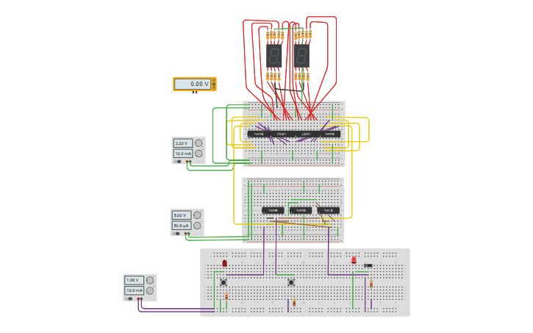

The above circuit is Tinker cad simulated circuit for one candidate and we make two similar and different circuits for number of candidates.

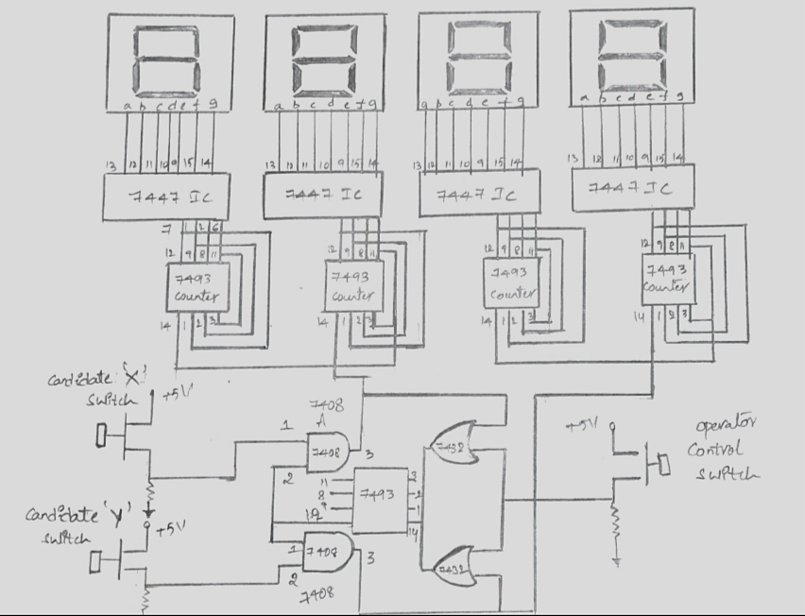

**Circuit diagram for voting machine for 2 candidates**

# WORKING OF CIRCUIT

The electronic voting machine responds to the push-button pulses sent by the voters, and counts the pulses that belong to each candidate, and displays that information on its own. Two switches are included in the circuit for two candidates, "A" and "B". First, by comparing the ID cards and photographs to the data, the operator will allow the voters to provide their valuable votes. The voter then gives permission for the operator to count his or her vote by pressing the control switch for the appropriate candidate. The operator will send by the control pulse by slide switch, making the machine ready to accept the pulse from the candidate's switch.

Every time a voter presses a push-button, the counter IC 7493 processes the pulse to count it at the counter section, and at the same time, the output stage of the operator pulse becomes low, disabling the machine and preventing any further pulses from being sent to the booth section for any unauthorized presses until the operator authorizes another voter to vote. The counter IC 7493 we increment its value for the chosen candidate. Finally, a 7-segment display with a decoder IC 7447 is used in the display count value for each candidate separately.

After the completion of voting process, the final count can be seen on the 7- segment display.

# TESTING AND TROUBLESHOOTING

# RESULTS AND DISCUSSION

# APPLICATIONS AND FUTURESCOPE

* **Elections**: The primary application of a voting machine project is to facilitate the electoral process e.g CR Election.
* **Accessibility**: Features such as braille displays, audio assistance etc. can be implemented.
* **Biometric Identification**: Incorporating biometric identification, such as fingerprint or iris scanning, can enhance the security the voting process by preventing fraudulent voting practices.
* **Integration with Smart Devices**: Future voting machines could integrate with smart devices such as smartphones or tablets, allowing voters to cast their votes online.

**CONCLUSION**

In conclusion, a voting machine project holds significant potential in revolutionizing the electoral process by streamlining voting procedures, enhancing accessibility, and ensuring the integrity and accuracy of elections. The future scope for such projects is broad and dynamic, with possibilities ranging from accessibility voting systems and biometric identification to the integration of smart devices. However, it is important to address concerns related to security, privacy, and public trust, as well as adapt the project to legal frameworks. With careful consideration of these factors and continued advancements in technology, voting machine projects have the potential to shape the future of elections, fostering inclusivity, efficiency, and transparency in democratic processes.

## Referenences:

## <https://www.researchgate.net/publication/274183078_A_Simplified_Electronic_Voting_Machine_System>